­

Lab II – AspectJ, IRM’s, and Reverse Engineering

CPS 499-02/592-02

Software/Language Based Security

Fall 2020

Dr. Phu Phung

Evan Krimpenfort

# Part I: Aspect-Oriented Programming and IRM’s

## Task I: Getting Started with AspectJ

This lab incorporates us working with AspectJ which will work on AOP and IRM’s inside of java files. This is the beginning of getting used to the program.

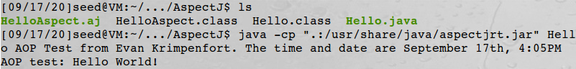

**Figure 1: using an AspectJ program given to us**

## Task II: Writing in AspectJ

AspectJ involves modifications before, during, and after a called function. In figure 2, we added a print out after the call “greeting.”



**Figure 2: Modifying the AspectJ program to user an after method**

## Task III: Using AspectJ to Modify Java ByteCode

### Packing Java ByteCode into a .jar file

You can also take this Aspect oriented program and weave it into a .jar file with the file you want to hook into. You can see the process in Figures 3, 4, and 5.

**Figure 3: Setting up Hello.jar**

### Weaving aspects to a .jar file

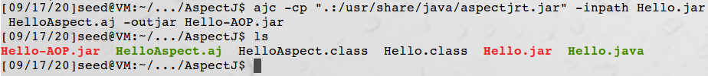

**Figure 4: Weaving AspectJ into Helslo.jar**

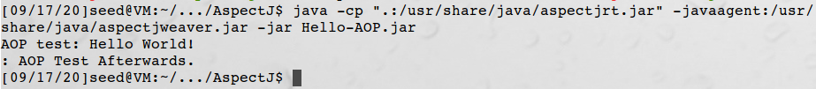

**Figure 5: running the weaved .jar file**

## Task IV: Getting Familiar with writing a security policy in AspectJ

### Demonstration

In this section of the lab, we will be flashing back to the last experiment where we used ShoppingCart.java. We want to weave ourselves into the program and spy on Wallet.setBalance (int balance). When the function is referenced, our AOP file, ShoppingCartAspect.aj, will print out the exact date and time the function was called and what the balance parameter was. The demonstration seen in figures 6 and 7 below show where and when the AOP file makes its mark.

**Figure 6: Starting the ShoppingCart-IRM.jar script**

**Figure 7: Showing the advice seen in the server**

### Test Description

When the setBalance(..) method is called, we see that the server shows the date, time, and balance after the function was called. How this happens is inside of the ShoppingCartAspect.aj program. Since I used the after method, this information comes to the server after a client purchases an item. This is nice in that now the user can see through the server on what the client’s balance is after the purchase.

### Aspect Source Code

To find the code, check it out in Appendix A.

Appendix A – ShoppingCartAspect.aj

﻿import java.time.format.DateTimeFormatter;

import java.time.LocalDateTime;

public aspect ShoppingCartAspect

{

after(int balance): call(* Wallet.setBalance(int)) && args(balance)

{

DateTimeFormatter dtf = DateTimeFormatter.ofPattern("yyyy/MM/dd HH:mm:ss");

LocalDateTime now = LocalDateTime.now();

System.out.println("Time is " + dtf.format(now) + ", balance is " + balance);

}

}

# Part II: Reverse Engineering

## Task V: Java ByteCode RE

### Aspect Code Examination

When looking at figures 8 and 9, the difference between each .jar file is the added ShoppingCartAspect.class. This class imports the code that we will see in the next part within figure 10.

**Figure 8: ShoppingCart.jar RE**

**Figure 9: ShoppingCart-IRM.jar RE**

### Advice Code

**Figure 10: Aspect Code replacement**

The Code that was injected in place of wallet.setBalance(k) was a try catch statement such that a throwable was made to run the aspect’s after statement code. If the catch statement was never triggered, the same after statement was still ran, making sure that this code was always executed.

### Code Mapping

Aspect-Oriented Programming is trying to add point cuts to an existing program without modifying the actual code of the program. These point cuts capture data at explicit execution points. AOP also involves breaking down those execution points into different interactions. This allows the programmer to focus on certain functions at certain times of execution, further enhancing the AOP experience. This level of abstraction is a huge part of AOP. Inline Reference Monitors are policies set inside of a finite-state automata. This provides a layer of policies between the program and anything outside of it. AOP can work inside of IRM’s by placing the point cuts at locations in the program of which those functions go outside of itself and into the OS.

## Task VI: Android RE

### Running an PK Android pp in an android emulator

**Figure 11: GPS of the Cordova App**

### Reverse engineer and modify a hybrid Android App

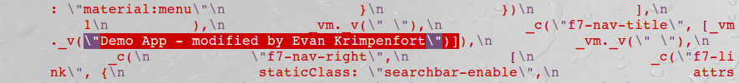

**Figure 12: Demo App Modification**

**Figure 13: Alert at the end Modification**

### Rebuild a Modified Android App

**Figure 14: Alert shown in new app**

**Figure 15: Name shown up by the Demo App space**

The theme here is seeing how easy it is to take an apk, download it, unpack it, and modify it for your own benefit. And, from rewriting the .apk, you can set your name to it and pass it off like its yours since you added your Alias to it.